Whole of Enterprise Architecture

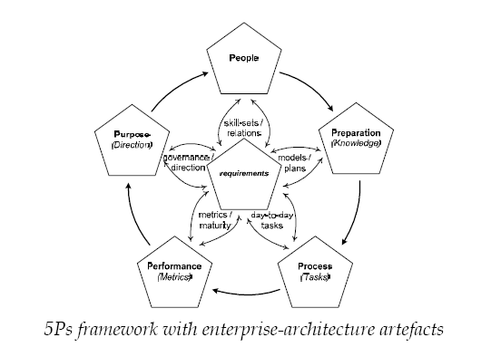

Purpose = Why
People = Who
Preparation = Where, When, and How
Process = puts plan into action
Performance = assess the results

Each of the P’s in the framework has a set of 5 views:
- Efficient
- Reliable
- Elegant
- Appropriate
- Integrated

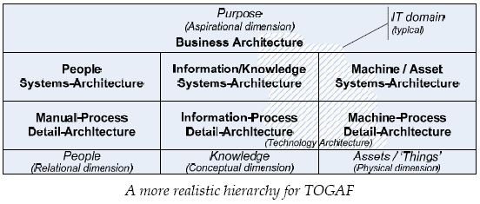

The architecture process has 2 major phases:
- Assessment of requirements (derived from customer needs)
  - Split existing composites into primitives
  - Derive high level abstracts from the low level primitives
  - Identify desirable common traits (consistency)
  - Use these traits to guide re-assembly of partially complete composites as building blocks (to promote reuse)
- Oversight of implementation (of design) to ensure result marries up to reqs.

Purpose of enterprise architecture is to support the changing needs of the business w/in the greater context of the value chain to enable proactive, flexible, adaptive change. The purpose of technical architecture is to position technology assets and investments in new technology to support enterprise architecture in a transparent manner.

Governance drivers:
- Culture (vision, values & principles)
- Policy (procedures & guidelines used to constrain activity)
- Strategy (metrics & drivers used to provide direction for activity)
- Compliance (regulation, legislation, standards used to minimize risk for activity)

RACI – Responsible, Assists, Consulted, Informed
CRUD – Create, Read, Update, Delete

Architecture Governance:

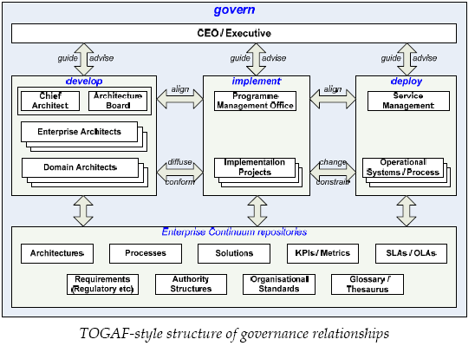

Compliance Stuff
- Architecture Charter
- Architecture Principles
- Architecture Procedures
- Architecture Standards

Operational Stuff
- Work Requests
- Work Statements
- Reports
- Compliance Statements
- Requirements
- Issues, Opportunities, Risks

Framework:
Taxonomy – naming of arrangement, relationship between items (organization & categorization of items) (naming conventions)

Ontology – study of meaning (meaning of items)
- Glossary
- Thesaurus
- Schema
- Metamodel

Primitives – atoms or root-elements of the architecture (these are the architectural elements)
Composites – molecules or combinations of primitives (these are specific instantiations of the architecture elements - patterns that can be used to build solutions)

Each cell in Zachman’s framework represents a class of primitives, while composites straddle (horizontally) across multiple cells.

The visible structures w/in the Zachman framework are the sets of models, which contain 3 categories of information:
- Content - nouns
- Context – adjectives (metadata)
- Connections - verbs

Architecture Layers
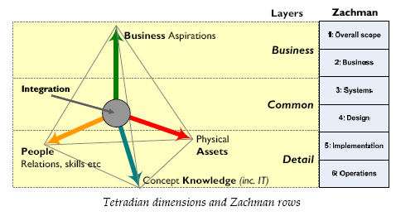

Framework (Primitives)

- WHAT – assets of any kind
- HOW – functions, activities
- WHERE – locations (physical, logical space, and relationships between data)
- WHO – capabilities and responsibilities (roles associated w/ a resource)
- WHEN – events and relationships between events
- WHY – reasons, decisions, constraints, triggers/conditions for the “reason”

Provides us with the grammatical sentence structure:
WITH assets DO functions AT location USING capability ON event BECAUSE reason

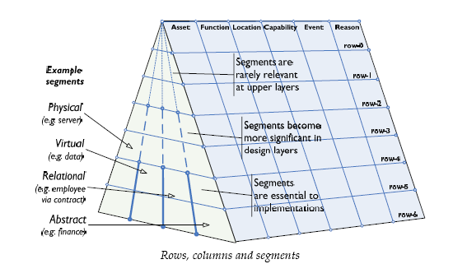

columns or content-types and primitive-types:
• What: assets of any kind – physical objects, data, links to people, morale,
finances, etc
• How: functions – activities or services to create change, described independently
from the agent (machine, software, person etc) that carries out that activity
• Where: locations – in physical space (geography etc), virtual space (IP nodes, http
addresses etc), relational space (social networks etc), time and suchlike
• Who: capabilities clustered as roles – may be human, machine, software
application, etc, and individual or collective
• When: events – may be in time, or physical, virtual, human or other event
• Why: reasons – decisions, constraints and the like, as in strategy, policy, business requirements, business-rules, regulations etc.
segments or sub-categories within the columns:
• physical: tangible objects (What), mechanical processes (How), physical or
temporal locations (Where), physical events (When); also align to rule-based
skills (Who) and decisions (Why)
• virtual: intangible objects such as data (What), software processes (How), logical
locations (Where), data-driven events (When); also align to analytic skills (Who)
and decisions (Why)
• relational: links to people (What), manual processes (How), social/relational
locations (Where), human events (When); also align to heuristic skills (Who) and
decisions (Why)
• aspirational: principles and values (What), value-webs and dependencies
(Where), business-rules (When); also align with principle-based skills (Who) and
decisions (Why)
• abstract: additional uncategorized segments such as financial (What, How),
energy (What) etc

Framework (Integration):
One framework I’ve found useful for this is Stafford Beer’s proven Viable System
Model (VSM), as it provides an explicit template of the relationships needed for
completeness of mutual support between services

Service-management overview
- delivery-services to external service-consumers: ‘muscular system’ (also ‘digestive system’ etc as service-delivery for internal systems and services)
- information-services and point-to-point information-flows: ‘nervous system’
- infrastructure-services such as building-management, energy-distribution, logistics, waste-management etc: ‘skeletal system’, ‘vascular system’ etc
- pervasive-services for distributed, pervasive actions and information-flows such as security, quality management, knowledge management, business-ethics, health safety and environment: ‘endocrine system’

Note: Service Management must link back to KPIs for the organization

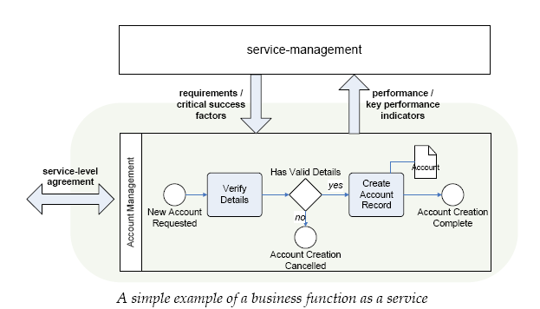
VSM
A viable system is composed of five interacting subsystems which may be mapped onto aspects of organisational structure. In broad terms Systems 1-3 are concerned with the 'here and now' of the organisation's operations, System 4 is concerned with the 'there and then' - strategical responses to the effects of external, environmental and future demands on the organisation. System 5 is concerned with balancing the 'here and now' and the 'there and then' to give policy directives which maintain the organisation as a viable entity.
- System 1 in a viable system contains several primary activities. Each System 1 primary activity is itself a viable system due to the recursive nature of systems as described above. These are concerned with performing a function that implements at least part of the key transformation of the organisation.
- System 2 represents the information channels and bodies that allow the primary activities in System 1 to communicate between each other and which allow System 3 to monitor and co-ordinate the activities within System 1.
- System 3 represents the structures and controls that are put into place to establish the rules, resources, rights and responsibilities of System 1 and to provide an interface with Systems 4/5.
- System 4 - The bodies that make up System 4 are responsible for looking outwards to the environment to monitor how the organisation needs to adapt to remain viable.
- System 5 is responsible for policy decisions within the organisation as a whole to balance demands from different parts of the organisation and steer the organisation as a whole.
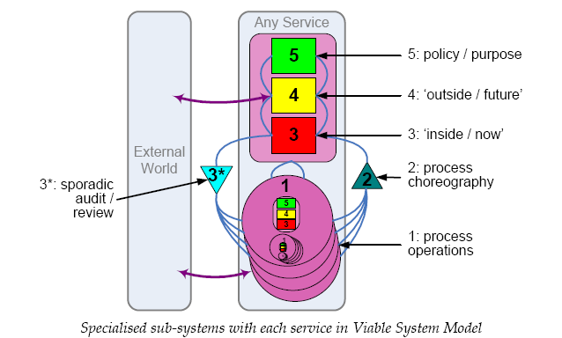
Methodology (Overview):

Methodology implements governance;
Governance maintains accountability in the methodology

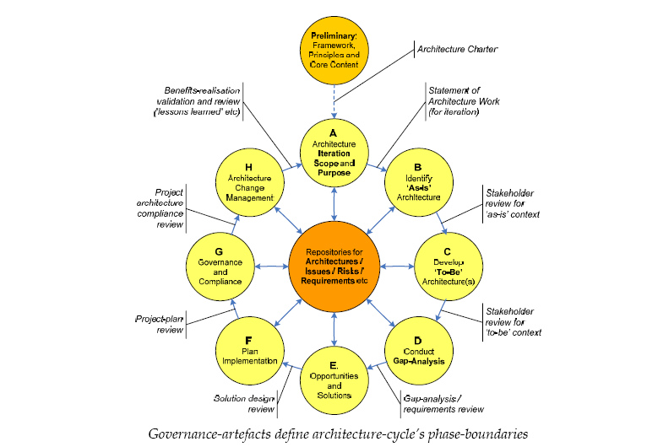

Phase P: Preliminaries – establish (or review) the architecture capability, the purpose, governance, framework, methodology and completion, and define a big-picture view of what the overall aims to achieve for the entire enterprise

Phase A: Establish iteration scope – identify the core business-issue(s) to be addressed, and scope (in terms of framework layers, columns and segments) to be covered in the analysis

Phase B: Assess current context – establish the current architectural description for the scope and business-issue identified in Phase A

Phase C: Assess future context – establish the required future-architecture for the scope and business-issue identified in Phase A

Phase D: Derive change requirements – establish the gaps between the current architecture (from Phase B) and desired future architecture (from Phase C), and the resultant change-requirements and constraints in relation to the scope and business-issue (from Phase A)

Phase E: Design solutions – work with solution-designers to assess options and trade-offs between requirements and constraints (from Phase D) to identify highlevel solution-designs for the required changes

Phase F: Plan implementation – work with governance, portfolio and change management teams to develop transformation blueprints, change-programmes and individual implementation-projects

Phase G: Guide implementation – work with programme and project managers to assist in resolving trade-offs between architecture and implementation

Phase H: Review lessons-learned – assess all issues arising from the architecture cycle, and identify (and, where appropriate, implement) any required changes to architecture standards and processes

To support dynamics properly, we need a sophisticated system of versioning and
prioritization, with dependencies mapped to different versions as required.

Methodology (Preparation):

Phase P – preliminaries
Key products include the Architecture Charter, Architecture Principles and core high-level content for the architecture framework.

Objectives
- validate the business principles, business goals, and strategic business drivers of the organization;
- define architecture principles that will inform the constraints on any architecture work;
- define the organization’s ‘architecture footprint’ – the people responsible for doing the architecture work, where they’re located, their responsibilities and so on;
- define the scope and assumptions (particularly if there’s a ‘federated architecture’ to be shared with others);
- define the overall framework and working details of the methodologies that are to be used to develop architectures within the enterprise;
- evaluate and confirm the selection of architecture tools, repositories, and repository management processes that you will use to capture, publish, and maintain architecture artifacts;
- define the scope of the architecture effort, and identify and prioritize its components;
- identify the relevant stakeholders, and their concerns and objectives;
- identify the key business requirements for the current architecture effort, and any applicable constraints;
- secure resources and formal approval to do the work.

Inputs and Outputs
Request for Architecture Work
Governance documents such as Architecture Charter, Architecture Governance Architecture Principles, Architecture Standards
Architecture-models repository
Requirements repository
Glossary and thesaurus
Issues/ risks registers
Architecture-dispensations register
Phase-completion report – stakeholder review of preliminaries

Step P1
• Architecture-models repository
• Requirements repository
• Issues register
• Risks / opportunities register
• Architecture-dispensations register
• Glossary and Thesaurus

Step P2 - Identify Architecture Principles

Step P3 – Identify applicable business policy, legislation and regulations
Step P4 – Identify applicable Standards
Step P5 – Identify core business-goals and business-drivers
Step P6 – Identify enterprise-architecture scope
Step P7 – Identify constraints
Step P8 – Identify stakeholders and concerns, business requirements, and overall
architecture Vision
Step P9 – Identify content for high-level models
• what: key data-items, key physical ‘things’ etc
• how: key processes, functions etc
• where: key locations, physical, virtual etc
• who: key capabilities, actors/agents, organisations etc
• when: key events, cycles etc
• why: key continuing aims, strategies etc

Step PX – Secure approval for Architecture Charter, governance, etc
Key Questions:
- Basics:
- What is the definition of “enterprise architecture” ?
- What is the current scope of the enterprise ?
- What is the current scope of EA ?
- Where (if at all) is EA positioned in the organization ?

- Architecture Process
- What is the understanding of the meaning & role of architecture w/in the enterprise ?
- What does an architect vs. an EA actually do ?
- What is the architecture process and how is this connected to the enterprise change process ?
- Is the present architecture ( and present understanding of architecture) essentially IT-centric or IT-only ? Is there a gap between this scope & the desired scope mentioned above for enterprise architecture ? What steps need to be taken to close the gap ?

- Artifacts & Tools
- What documents, models & other artifacts are created in the architecture process ?
- What are the business purposes of each artifact ?
- Who are the audiences & stakeholders for each artifact ?
- What toolsets do you use to create, maintain & distribute each type of artifact ?
- What “toolset gaps” do you need to resolve in the architecture practice ?

- Architecture (Purpose)
- How do you ensure an emphasis on business purpose in the architecture ?
- Who defines business purpose for the architecture ?
- How do you ensure business engagement in architecture development and use ?
- How do you manage complexity and dynamics in the architecture ?
- How do you ensure a balance between analysis & holistics in the architecture ?

- Architecture (Purpose - Business Driven)
- What are the business drivers in the enterprise ?
- What are the business drivers for the architecture ?
- How do we ensure those business drivers are tracked w/in the architecture ?
- Who has ultimate responsibilt8y for each business driver & its resolution ?

- Architecture (Governance)
- Where does EA sit w/in the enterprise ?
- Who manages governance of EA ?
- What governance models, frameworks, tools & methodologies do we use for EA ?
- What governance is used for change-mgmt ?

- Architecture (Governance – Roles & Responsibilities)
- How do you identify architecture roles, responsibilities & stakeholders ?
- What is the respective “needs to know, needs to use” for each stakeholder (for each item – per CRUD), and for the deployment of ach item-type ?
- How do we assign & verify architecture roles & responsibilities ?
- How do we manage changes in these roles & responsibilities ?

- Architecture (Governance – Products)
- What products & other artifacts are created and used ?
- How are these produced and by whom ?
- Who has the responsibility for each artifact ?

- Framework (Overview)
- What frameworks & other conceptual models do you use for architecture ?
- In what ways have the underlying metamodels been adapted to better describe the enterprise ?
- What repositories & toolsets are used in the architecture ?
- Which frameworks do those toolsets support ?
- How do we partition our architecture into vertical layers ?
- How do we identify & differentiate between layers ?
- How do these layers align with the various business drivers ?

- What do you recognise as a ‘primitive’ in an architectural sense?
- How do you distinguish between primitives and composites?
- If you use an EA toolset, what primitives does it support?
- How does it structure those primitives and their relationships with each other? –i.e. what taxonomy does it use?
- What means – if any – does it provide to separate out primitives from the composites and other ‘solution building blocks’?

- Framework (Integration)
- How do you use your existing architecture frameworks to tie the enterprise together? What would you need to amend or add, to improve this integration?
- Do your existing frameworks view the enterprise only as some kind of machine, as an arbitrary collection of components without any inherent purpose? If so, what would you need to amend or add so as to support the ‘living enterprise’ metaphor?
- Does your framework already support a ‘service-oriented architecture’? If so, is it only for low-level IT, or can it extend across the whole enterprise?
- Do you have an enterprise glossary and thesaurus? If so, to what extent is it integrated with your enterprise architecture? What could you do to enhance that integration?
- What are the boundary-issues for your existing architecture? How does your architecture manage the difference between ‘organisation’ and ‘enterprise’ –especially when the bounds of the enterprise extend beyond the borders of the organization? What issues arise for management of your frameworks in such circumstances?

- Methodology (Overview)
- What formal methodology – if any – do you use for your current architecture?
- What are the boundaries of that methodology – for example, does its scope address only IT-systems or IT-services?
- How do you address architectural concerns beyond the nominal scope of the methodology?
- How do you address the dynamics of architecture – versions, interactions, lifecycles and so on – within the methodology?
- If you use an architecture toolset, in what ways does the toolset support or constrain the methodology?
- What processes and products are used for governance of that methodology?

- Methodology (Preparation)
- What methodology do you use at present for architecture?
- What processes does it provide for preparation for architecture?
- What formal process – if any – do you use for managing, reviewing and updating the methodology itself?
- In what ways – if any – is the current architecture linked to the high-level ‘universals’ of the enterprise?
- What is the current scope and authority for ‘enterprise architecture’? Under whose governance? If it does not have a true enterprise-wide scope and authority, what would need to change in order to attain these?

